
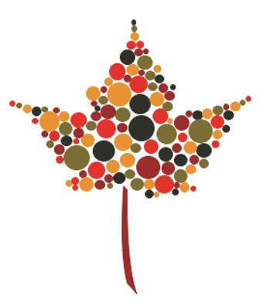

Mi’kmaq Bursary Program

The Carter Simpson Mi’kmaq Award is for Mi’kmaw students entering any year of a full time accredited post-secondary education program. It is a non-renewable award of $1,000. Up to 3 recipients will be chosen in 2026. Past winners can re-apply each year for up to 4 years while enrolled in an accredited post-secondary program.

Applications are accepted from June 1, 2026 to July 10, 2026

Applicants must meet the following requirements:
- Be a registered Mi’kmaw person with one of the 13 Mi’kmaw communities in Nova Scotia.
- Be a permanent resident of Nova Scotia.
- Have been accepted to attend an accredited post-secondary program in Canada.

How to Apply

Send your application in letter format to info@cartersimpson.ca with “Bursary Program” in the subject line and providing the following information:

- Your Name and community
- Current School and Grade or Year
- Post-Secondary Institution you are/will be attending
- Name of Program
- Date of Acceptance
- Start Date and End Date of Program
- What you aspire to do after you graduate from your chosen program
- Details of community service work
- Details regarding financial need (how will this bursary help you?)
- A copy of your High School transcript and/or any relevant post-secondary transcript(s) (unofficial is acceptable)

Criteria

Awards will be assessed based on the following criteria:
- Contributions made to the community.
- Future aspirations.
- Financial Need.

Selection Process

Apply by July 10, 2026 to be considered for a 2026 Bursary.

A Selection Committee in conjunction with The Confederacy of Mainland Mi'kmaq will review the applications and make decisions based on the criteria outlined above (community contribution, future aspirations, and financial need).

The chosen recipient(s) will be notified in August 2026 and an announcement will be posted on Carter Simpson’s social media pages and website.

The bursary funds are provided upon proof of enrolment.



3
Bursaries
$1,000
each

cartersimpson.ca
902-444-7227

A Law Firm Rooted in Your Community

