**EMPLOYMENT OPPORTUNITY**

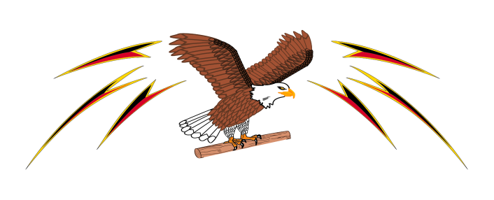

The Confederacy of Mainland Mi’kmaq

**Department of Finance & Administration**

***Communications Officer***

**About CMM**

The Confederacy of Mainland Mi’kmaq (The CMM) is a Tribal Council representing eight, Mi’kmaq communities of mainland NS. Our mission is to proactively promote and assist Mi’kmaq communities’ initiatives towards self-determination and enhancement of community. The CMM main office is in the Millbrook Mi’kmaw Community in Nova Scotia and has over 190 Employees. The CMM’s Department of Finance & Administration is currently looking for an energetic, mature, and independent candidates to fill the position of: ***Communications Officer.***

**Position Overview**

Under the direction of the Director of Finance & Administration, and reporting to the Communications Manager, the Communications Officer will be responsible for providing effective communications within the CMM, Advisory Committees, leadership, and external partners. The Communications Officer is responsible for developing communication materials relative to department programs and projects, documenting communities’ activities, workshops, and events, increasing awareness of capacity development opportunities within Mi’kmaw Communities, preparing content, picture and graphics for news articles, social media sites, etc. and the facilitation of media relations and/or inquiries.

**Overview of General Responsibilities:**

* Prepare general communications correspondence and reports as directed by Communications Manager or other team members.
* Develop promotional items for programs to be distributed at various events to promote the Departments within Mi’kmaw communities.
* Contribute to and maintain an annual communications strategy/plan under the direction of the Communication Manager and Directors.
* Assist staff with the development of educational and communication materials.
* Monitor and evaluate the operations of overall digital communications within Departments.
* Establish work priorities and ensure deadlines are met and communication protocols and policies are adhered to.
* Support in development of presentations and briefings for management.
* Attend periodic meetings that may be required and/or requested by Directors.
* Participate on Committees and on Boards as requested by Directors.
* Continually seek education and training to remain culturally responsible and sensitive to needs of client(s).
* Any other related duties as required and as requested by the Executive Director or Directors, or Communications Manager such as to participate on committees or special projects.

**Position Requirements:**

* Post-Secondary diploma or certification in a public relation, communications, education, or related field.
* Minimum of two-years’ experience in the communications or public relations field.
* Strong work ethic and ability to work in an environment requiring discretion and confidentiality.
* Relevant social media and general media training.
* Experience working in a fast-paced environment.
* Proficiency in MS Office (Word, Excel, PowerPoint and Outlook etc.).
* Ability to apply creativity and innovative thinking to community focused solutions.
* Ability to be adaptable, flexible, and manage multiple priorities and deadlines.
* Valid driver's license, reliable transportation, and ability to travel within Nova Scotia as required.
* Experience working in or with First Nation communities an asset.
* Canadian Public Relations Society Membership would be an asset, but not required.

**Why work with us?**

The Confederacy of Mainland Mi’kmaq (The CMM) is well known throughout Canada as a professional organization that is committed to providing a pleasant and healthy working environment for all its employees. As an organization, we understand that a great work/life balance is essential to success. As a full-time employee you can expect:

* An atmosphere that is a great mix of fun and professionalism, and deeply family oriented.
* Enrollment in the organization’s benefits packages on your first day of employment with no waiting period, which includes Health & Dental, and Employee Assistance Program (EAP).
* Generous amounts of paid time off including Paid Statutory Holidays plus St. Anne’s Day and Aboriginal Day, Summer Shutdown (2 weeks), Christmas Shutdown (roughly 2 weeks), plus minimum of 1-week additional vacation time (up to 2 weeks with 10 years of service).
* Social Committee, Staff Days, Staff Knowledge Days, etc.

**If you would like to join The CMM Family, please see below on how to apply for this position.**

Salary/Employment Term: $49,071 to $55,000 per year based on qualifications and experience. This is a permanent contract (pending one-year probationary contract).

**Application Deadline: Open until Filled**

Submit **Cover Letter** and **Resume** to: **Human Resources**

**c/o The Confederacy of Mainland Mi’kmaq**

**PO Box 1590, Truro, Nova Scotia B2N 5V3**

**Email:** [HR@cmmns.com](mailto:HR@cmmns.com)

*We are an equal opportunity employer; however, qualified Aboriginal applicants will be given priority in accordance with the Aboriginal Employment Preference Policy of the Canadian Human Rights Commission.* ***Only those applicants who qualify for an interview will be contacted****. The successful candidate may be required to submit a current criminal record check.* ***Applicants must provide proof of Canadian Citizenship of Permanent Residency.***